CUPE 59 AGM Teams meeting quick tips
Select the Teams link from the AGM invitation to join the meeting virtually.
Below is an example of what the link will look like:
Microsoft Teams should open on your computer automatically. Select the ‘Join Now’ button
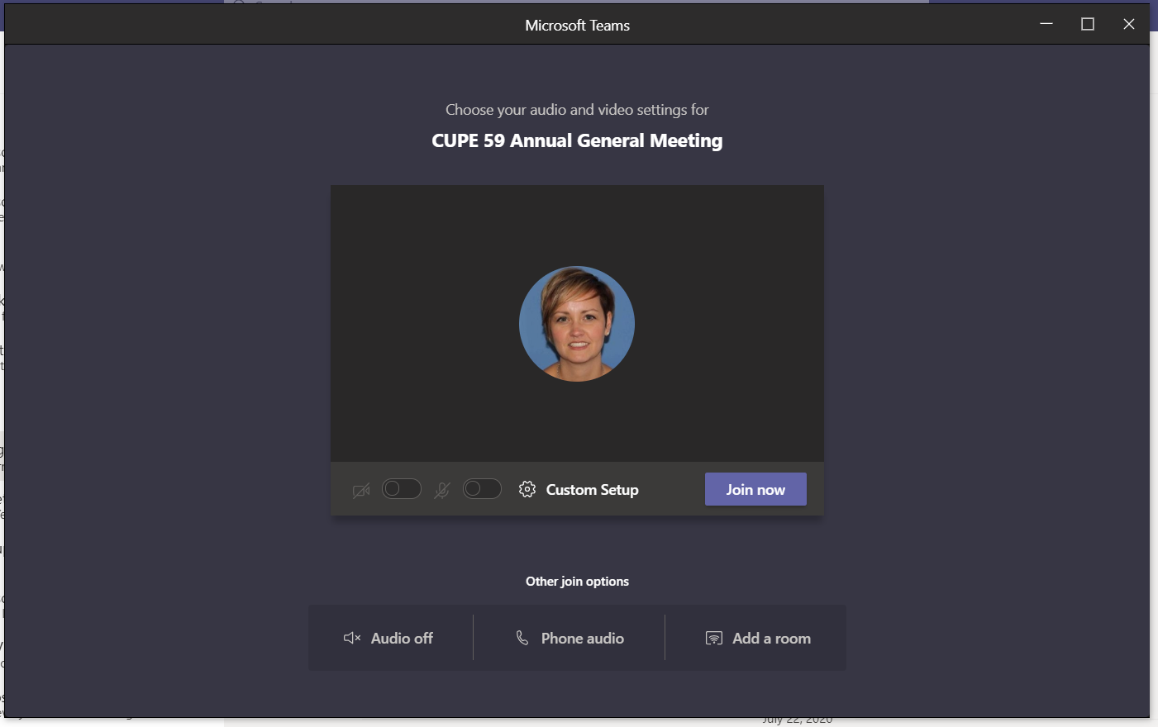
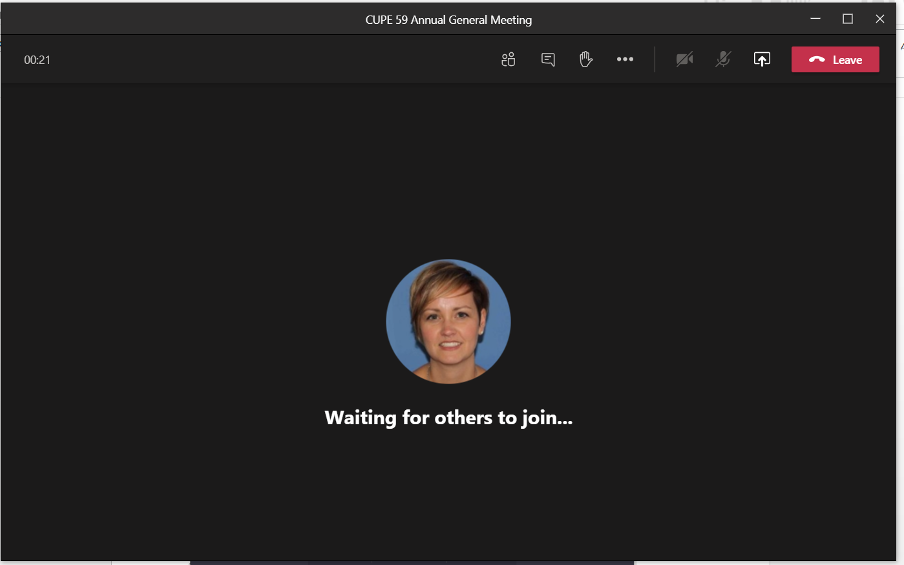
Use the toolbar to navigate through the various features:
1) Show participants
2) Show conversations – here you can enter messages in the ‘chatroom’. Virtual attendees will use this function for voting.
3) Raise your hand – this allows the moderator to call on participants to provide verbal comments in an orderly fashion
4) Turn on/off your camera
5) Turn on/off your microphone – please mute until called on for comments
6) Select to leave the meeting
6

5

4

3
2
1

