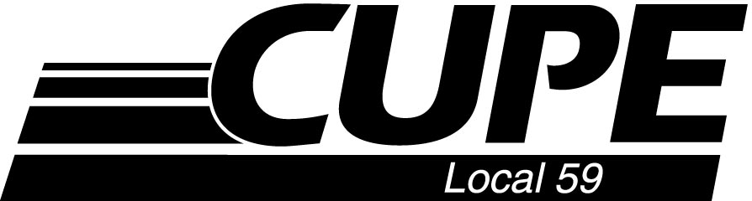

NOTICE OF
SPECIAL MEMBERSHIP MEETING

RATIFICATION OF
COLLECTIVE AGREEMENT

TUESDAY, FEBRUARY 4, 2020
7:00 p.m.

ARMY NAVY & AIRFORCE VETERANS CLUB
359 – 1st Avenue North (basement)

Meeting will commence at 7:00 p.m.
Voting will follow and members will have until 9:00 p.m. to cast their ballot.

